

CAPSTONE PROJECT REPORT
Report 1 – Project Introduction

– Danang, August 2026 –
Table of Contents
I. Record of Changes 3
II. Project Introduction 4
1. Overview 4
1.1 Project Information 4
1.2 Project Team 4
2. Product Background 4
3. Existing Systems 4
3.1 System name1 4
3.2 System name2 4
4. Business Opportunity 4
5. Software Product Vision 5
6. Project Scope & Limitations 5
6.1 Major Features 5
6.2 Limitations & Exclusions 6

I. Record of Changes
Date | A*  M, D | In charge | Change Description
16/06/2026 | A | LongNLT | Create the project introduction document
 | A | DatNT
*A - Added M - Modified D - Deleted

II. Project Introduction

1. Overview

1.1 Project Information
- Project name: Building a Recycling Scrap Supply Chain Management and Connection System
- Project code: ReTrack
- Group name: SE_44
- Software type: Web, Mobile App

1.2 Project Team
Full Name | Role | Email | Mobile
Nguyen Thi Thuy Hoai | Lecturer | hoaintt40@fe.edu.vn | 0982827763
Ngo Sy Gia | Leader | giansde180117@fpt.edu.vn | 0967661031
Nguyen Lan Viet | Member | vietnlde180776@fpt.edu.vn | 0337258176
Pham Hong Quan | Member | quanphde180093@fpt.edu.vn | 0942928578
Nguyen Le Tieu Long | Member | longabc932@gmail.com | 0393712547
Le Van Minh Nhat | Member | nhatlvmde180876@fpt.eddu.vn | 0774591571

2. Product Background
In many recycling hubs today, the management of scrap collection and processing is still conducted manually, relying on paper logs or disparate spreadsheets. This manual approach is highly susceptible to human error, such as incorrect weight recordings, mismatched material types, or lost transaction slips. As a result, depot owners and recycling factories often lack real-time visibility into the movement of materials across the supply chain, leading to inventory discrepancies, financial losses, and operational delays. Meanwhile, drivers and administrative staff spend significant time each day manually reconciling weight tickets and invoices, which reduces overall productivity and increases the risk of commercial fraud.
Key user groups:
1. Sellers : Require a simple platform to list their scrap, access transparent market pricing, and track their total recycling impact and earnings in real time.
2. Depot Owners: Need a robust digital system to manage incoming inventory, consolidate raw scrap into bulk commercial batches, and reach a wider network of recycling factories for better sales opportunities.
3. Collection Staff: Field employees affiliated with depots who receive real-time order broadcasts, claim available pickup jobs based on their availability, perform on-site weighing and payments, and transport collected materials back to the depot.
4. Driver: The order delivery process is monitored by the customer through check-in and checkout.
5. Recycling Factories: Require a reliable source of high-quality bulk scrap with verifiable weight and origin data to optimize their production cycles and ensure regulatory compliance.
ReTrack addresses this gap by establishing a closed-loop digital ecosystem where sellers, depots, drivers, and factories are connected through a unified web-based platform. The system integrates a dual-weight verification process—requiring both the Depot's Weight Ticket and the Factory's Weight Verification—with automated image uploads to Cloudinary. This ensures that every kilogram of scrap is accounted for, eliminating the possibility of "forgotten" or falsified records. Real-time marketplace integration allows depots to list bulk batches immediately, while factories can browse and purchase supply with full transparency.
Additionally, a built-in subscription module allows recycling factories to upgrade to VIP status, granting them exclusive access to high-volume supply sources and advanced analytical reporting. The reporting engine automatically generates detailed summaries of inventory turnover, financial logs, and supply chain performance, empowering stakeholders to make data-driven decisions for business growth.
In summary, ReTrack was conceived to eliminate:
1. Errors and fraud inherent in manual weight recording and invoicing.
2. Lack of transparency in material movement from depot to factory.
3. Fragmented communication among sellers, depots, drivers, and factories.
4. Inefficient inventory management and slow batch-to-market turnover.
By unifying marketplace connectivity, dual-weight verification, and digital logistics tracking within a single platform, ReTrack enhances supply chain integrity, streamlines operations, and delivers a premium experience for all recycling stakeholders.

3. Existing Systems

3.1 Vechaioi
(Recycling Platform)
Website link: https://vechaioi.vn

a. System Actors
Sellers: Individual households, small-scale collectors, or businesses who install the platform to post scrap listings, check daily material prices, and schedule collection appointments.
Depot Owner (The Platform Admin): The single administrator and centralized warehouse operator who manages all incoming sell requests, updates market price lists, controls inventory, and dispatches collection staff.
Collection Staff: Internal field workers deployed by the platform to travel to the sellers' locations, weigh the scrap, make payments, and transport materials back to the single hub.

b. Main features
Scrap Listing & Scheduling: Allows sellers to create posts with descriptions/photos of their scrap and book a specific time slot for pickup.
Centralized Price Management: A single dashboard for the administrator to update daily market rates for various material types (paper, plastic, metal, etc.).
Basic Financial Ledger: A simple tracking module for sellers to view their history of completed transactions and total accumulated earnings.
Staff Dispatching System: Tools for the depot owner to assign pickup tasks and coordinates to internal collection staff.

c. Advantages
High Operational Control: Operating a single, centralized depot allows the platform owners to maintain absolute control over material pricing, quality inspection, and localized operations without third-party conflicts.
Simplified User Experience: A straightforward, minimal workflow that makes it highly intuitive and easy to use for non-technical sellers or older individuals.

d. Disadvantages
Severe Scalability Bottleneck: Limited strictly to a single geographic location and one warehouse. It cannot scale nationwide or handle high-volume, multi-regional supply chains.
No Factory Integration: Completely lacks a B2B marketplace to connect directly with recycling factories. The single depot must manually find factory buyers offline, leading to slow inventory turnover and fragmented communication.
Lack of Independent Logistics Tracking: Does not support independent third-party drivers or advanced transit monitoring (no real-time check-in/checkout verification).
High Risk of Manual Errors: Lacks a rigorous dual-party weight verification mechanism, making transactions highly dependent on manual recording and vulnerable to human error or fraud during pickup.

3.2 GRAC
GRAC provides comprehensive waste management software solutions, often targeting government (B2G) and large enterprises (B2B).

a. System Actors
- Local Authorities/Government: Oversight of waste collection contracts and municipal data.
- Waste Collection Companies: Professional entities managing fleets and household data.

b. Main features
- SaaS for Waste Management: Tools for contract management, employee tracking, and payment history.
- GPS Fleet Monitoring: Real-time tracking of garbage trucks.
- EPR (Extended Producer Responsibility) Compliance: Helping businesses meet environmental laws.

c. Advantages
- Strong institutional and compliance focus.
- Scalable for municipal-level operations.

d. Disadvantages
- Institutional focus: May be too complex for smaller private scrap depots and independent drivers.
- Market connection: Less focused on the commercial marketplace for selling bulk processed batches to factories.

4. Business Opportunity
Market Trends and Fit
- Circular Economy Momentum: Education on waste classification is evolving into institutionalized recycling supply chains, driving factories to adopt cloud-based, verified solutions for material procurement.
- Extension of Digital Workflows: As the recycling industry digitizes inventory and finance, there is a natural extension into logistics, demanding real-time visibility and fraud prevention.
- Convergence on Unified Platforms: Stakeholders favor integrated systems that bring sellers, depots, and factories under one roof, reducing tool-sprawl and simplifying the audit trail.
Solving Key Problems
- Error-Prone Manual Processes: Traditional paper logs and spreadsheets lead to data gaps and time-consuming reconciliation. ReTrack automates weighing and invoicing, ensuring accuracy and freeing staff for higher-value tasks.
- Limited Visibility & Fraud Concerns: Without dual-weight verification, depots and factories lack reassurance. ReTrack's digital tickets and Cloudinary-backed images deliver continuous validation, bolstering transaction trust.
- Fragmented Communication: Multiple channels (calls, SMS) create delays and information loss. ReTrack centralizes listings, bids, and logistics jobs in one app, ensuring everyone receives the right data at the right time.
- Inefficient Inventory Turnover: Static stock and manual sales efforts inflate costs. ReTrack’s batch consolidation engine and wholesale marketplace optimize inventory throughput and anticipate demand.
Key Features and Benefits
Feature | Benefit
Dual-Weight Verification | Tamper-proof, verified weight records eliminate manual errors and commercial fraud.
Wholesale Marketplace | Direct connection between depots and factories; ensures faster sales and competitive pricing.
Batch Consolidation | Smarter packing of raw scrap into commercial batches increases market value and shipping efficiency.
Logistics Job Board | Simplified transport booking and secure check-in/out tracking without manual coordination.
Reporting & Analytics | Actionable insights on inventory turnover, financial performance, and supplier reliability.

Market Needs and Opportunities
- Digital Transformation Imperative: The recycling sector is under pressure to modernize beyond simple collection, extending digital workflows to processing and wholesale for efficiency.
- Heightened Integrity & Compliance: Rising environmental standards make verified origin and weight data mission-critical for recycling factories.
- Specialized Supply Chain Services: Niche requirements (e.g., specific scrap grades, bulk batching) demand flexible platforms that legacy accounting software cannot support.
- Integration Challenges: Many depots struggle with high overhead when linking disparate weighing, sales, and logistics systems; a unified SaaS platform simplifies management.

5. Software Product Vision
For scrap sellers, depot owners, transport providers, and recycling factories who need a secure, transparent, and efficient way to manage the recycling supply chain, ReTrack is an all-in-one, cloud-based platform designed to enhance integrity, automate operations, and foster clear marketplace communication.
ReTrack empowers users with:
- Dual-Weight Verification: Digital weighing records and image backups that eliminate manual errors and ensure tamper-proof records.
- Wholesale Marketplace: Live bulk batch listings and transport job tracking, giving depots and factories up-to-the-minute visibility.
- Instant Notifications: App alerts for key events—"Listing Accepted," "Driver Checked-in," or "Weight Discrepancy Alert"—so everyone stays informed.
- Dynamic Inventory Management: Logic-driven batch consolidation enabling depots to adjust supply on the fly for factory demands.
- Self-Service Invoicing & Payments: Automatic e-invoice generation with subscription-based VIP access for advanced procurement tools.
- Comprehensive Dashboards: Role-based views for all participants—complete with reporting and analytics on turnover, performance, and financial logs.
By uniting weighing, marketplace, logistics, and billing in one intuitive web application, ReTrack not only elevates supply chain integrity but also drives operational excellence and strengthens trust among all stakeholders.

6. Project Scope & Limitations

The ReTrack platform aims to digitize and streamline the recycling supply chain management, replacing manual processes with a secure, real-time, cloud-based system accessible via a web interface. The system serves four main user groups: scrap sellers, depot owners, drivers, and recycling factories. Its goal is to ensure transaction transparency, inventory efficiency, and fraud-free logistics.
This section outlines the key features to be developed in the initial release, along with limitations that set realistic expectations for stakeholders.

6.1 Major Features
- FE-01: Scrap Listing Creation: Sellers publish requests with pickup times, and photographs.
- FE-02: Seller Transaction Dashboard: Tools to track earnings, kilograms recycled, and order status.
- FE-03: Order Broadcasting & Staff Claiming: System broadcasts open pickup requests to nearby collection staff. Available staff can view details and claim open orders on a first-come, first-served basis.
- FE-04: On-Site Weighing & Payout Verification: Collection staff record physical weights on-site, calculate payouts, and generate digital weight receipts verified by both staff and seller.
- FE-05: Depot Inventory Management: Monitoring stock quantity by type and shipment status.
- FE-06: Bulk Batch Consolidation: Packing raw scrap into commercial batches for wholesale.
- FE-07: Factory Marketplace: Connecting depots and factories for bulk batch sales.
- FE-08: Logistics Job Board: Marketplace for drivers to accept transport shipments.
- FE-09: Transport Check-in/Check-out: Tracking shipments at designated locations.
- FE-10: Premium Subscription: VIP status for factories to unlock exclusive batches and analytics.
- FE-11: Admin Management: Comprehensive user, role, and permission oversight.
- FE-12: Monitoring & Reporting: Overview dashboards and data export capabilities.

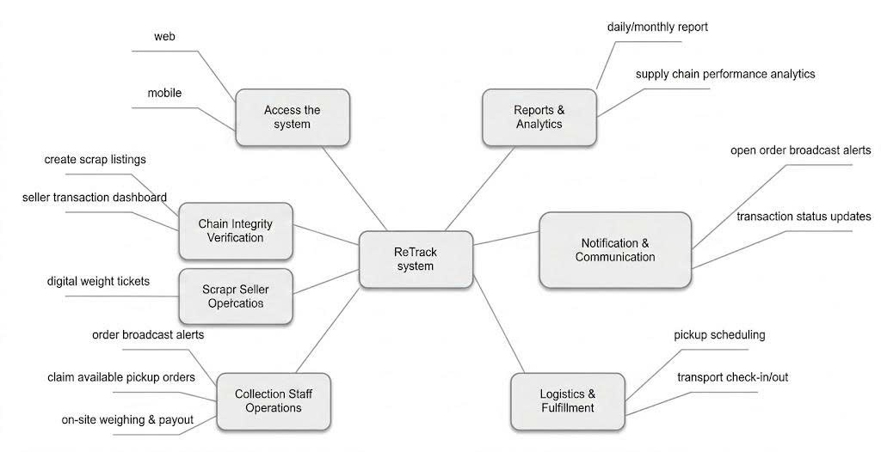

6.2 Limitations & Exclusions
- LI-01: Initial release focus is a web-based platform; a dedicated mobile app for drivers/sellers may be part of future phases.
- LI-02: Integration with third-party ERPs or government waste databases is excluded from the first version.
- LI-03: Real-time GPS tracking for pickups is limited to coordinates; active live tracking of pickup vehicles is not included initially.
- LI-04: Multilingual support is currently limited; the primary interface will be in English/Vietnamese.
- LI-05: Offline functionality is not supported; a stable internet connection is required for all transactions.
- LI-06: The payment module will be limited to a single local payment gateway for subscription upgrades.

